What Kind of Differences Do Politicized Messages Make? Effects of Media Consumption on Individual Attitudes to COVID-19 Issues

OOO,a*

aDepartment of Public Administration and Policy, Rockefeller College of Public Affairs and Policy, University at Albany, State University of New York, Albany, NY 12222, USA

**Abstract**.

Recent studies report that politicized messages from conservative media outlets, such as Fox News, can undermine people’s compliance with social distancing and face-covering, arousing a suspicion that media polarization may mislead people to disbelieve in the lethality of the pandemic and the need for the public health guidance1,2. However, it is still unclear what kind of differences the politicized messages make in people’s perception. Even if the messages are politicized, mass media might have contributed to promoting on-going prevention efforts by signalling the risk of the infection, given that mass media can give a signal of danger or stimulates threat perception of the infection3,4. Here we examine how the extent of media consumption of Coronavirus and Fox News viewership affect people’s attitudes toward four types of COVID-19 issues: (1) perceived compliance with social distancing and support for requiring face covering; (2) COVID-19 anxiety; (3) trust in governments and medical scientists; and (4) perception of government interference during the pandemic. With an online survey with 1 128 respondents, we found a strong convergence in the predicted outcomes, except for the perception of government interference, along with the increase of the extent of media consumption, in both Fox News viewers and the others. The results imply that the motivation of the non-compliance may exist somewhere else other than the change in individual beliefs and be moderated by threat perception.

**\*** E-mail: ychoi2@albany.edu

# INTRODUCTION

The COVID-19 pandemic has posed an unprecedented public health challenge to the world, generating about 68 million infected and 1.5 million deaths globally as of early December 2020. In response to the surge of cases, governments have widely expanded social distancing measures, including 6-feet rules and stay-at-home orders, and required face-covering at public spaces beginning from late Spring. Without proper pharmaceutical treatment and a vaccine, encouraging people to participate in those measures would be the most effective and essential strategy against the spread of the SARS-CoV-2 virus5–8.

Science provides solid evidence that social distancing and face-covering effectively prevent SARS-CoV-2 virus transmission7, however, as recent studies pointed out, the problem of politicized messages in mass media can disrupt people’s compliance. In particular, conservative media outlets in the US, especially Fox News, which is one of the largest cable channels in the country, have spread scepticism of the effectiveness of social distancing and face-covering1,9,10. Studies associate the exposure to Fox News with the non-compliance with stay-at-home orders1,2 and vulnerability to misinformation in the pandemic11,12.

These findings arouse a suspicion that Fox News may mislead the consumers to disregard in the seriousness of the pandemic and the need for on-going prevention efforts. If the politicized messages stimulated partisan difference and lead to motivated reasoning by making people belittle the seriousness of the pandemic and distrust public health guidance, we would therefore expect high consumers of media in different “bubbles” to have sharply differing views on overall public health issues13,14. However, it is still unclear what kind of differences the politicized messages make in people’s perception. Recent polls find that people generally believe experts when it comes to the pandemic issue, even though the partisan differences also exist15,16. Despite the skeptical views, mass media still plays a critical role in advancing public communications of public health information3,4. Threat perception is also an important part of human motivation2. For example, rich evidence explains that the perceived risk of victimization is a strong predictor of gun ownership even when controlling for partisan difference17,18. If the messages from mass media, even if they are politicized, still have an informational role by signaling the increasing risk in the epidemic, what the politicized messages make a difference in the level of compliance perhaps be something subtle rather than the overall belief of the seriousness of the pandemic and effectiveness of the prevention efforts.

To add a piece of evidence on this issue, we examine how the extent of media consumption of SARS-CoV-2 virus and Fox News viewership affect people’s attitudes toward four types of COVID-19 issues: (1) perceived compliance with social distancing and support for requiring face covering; (2) COVID-19 anxiety; (3) trust in governments and medical scientists; and (4) perception of the government interference during the pandemic. Using a survey that included 1,194 respondents, we compare to see if the extent of media consumption affects beliefs of Fox News viewers and the other respondents differently.

We may find sharply differing views on the COVID-19 issue if Fox News has made its customers disbelieve in the pandemic and the on-going prevention effects. Interestingly, however, we find a consistent increase in the outcomes in both groups, except for perceptions of the government interference, along with the increase in the extent of media consumption of SARS-CoV-2 virus in the past week. This implies that the messages from media outlets might make a difference in perception of the appropriate level of social distancing and response against the pandemic rather than changing individual beliefs of how the pandemic and the effectiveness of the countermeasures are real.

I can add some more here, but it seems to me that a key question here is trying to suss out the relative importance of media consumption, media “bubbles”, and ideology/party id/support for Pres Trump on people’s health behaviors in a politicized pandemic. I’m not sure we can successfully tease these apart, but I do think it is interesting that we find that regardless of which networks you watch, consuming more media seems to make people more worried and follow guidelines (maybe worry should be another outcome rather than a covariate?). And if you look at the relative magnitude of effects, consuming more media has a stronger effect than ideology. I think we could do the analysis a little differently to tease this out. I think we should interact Fox News watching with the amount of media consumption. Also, could we measure support for Donald Trump somehow (maybe based on having voted for him in 2016)? The other variable that seems to be missing here is other forms of media consumption (particularly social media). Are people who get their info from social media less likely to SD and support FC?

Could we also look at “myths” about the cause of the virus and see if that correlates with type of media consumed/media outlets as another outcome potentially?

Key theoretical motivations:

* Free media is a cornerstone of democracy (watchdog of government), but has our degree of media polarization undermined its informational role? How do we get “factual” information from the media when different media outlets are giving conflicting accounts? Is the media still a trusted/venerated institution or is it perceived as “fake news”.
* Ideology and disease politicization – research finds that people generally believe experts when it comes to health risks, except when the issue environment becomes politicized. In those instances, people engage in motivated reasoning. We would therefore expect high consumers of media in different “bubbles” to have sharply differing views (what’s interesting is that this is not what we find). [see here: Albertson, Bethany and Shana Kushner Gadarian. 2015. *Anxious Politics: Democratic Citizenship in a Threatening World.*New York: Cambridge University Press]

# RESULTS

We present the major findings in Figs. 1-4. The figures show margins plots that indicate the associations of the extent of media consumption of SARS-CoV-2 virus with the outcome variables. In the plots, the vertical axis indicates the likelihood of the outcome variable being 1 while the horizontal axis presents different media consumption levels of SARS-CoV-2 virus in the past week. See the supplementary material for more details of how the variables are coded.

The results are based on ordinary least square specifications, however, we also find very robust findings with logistic regressions. See eTables 7-10 in the supplementary material for more details of the results based logistic regressions.

## Social Distancing and Face Covering

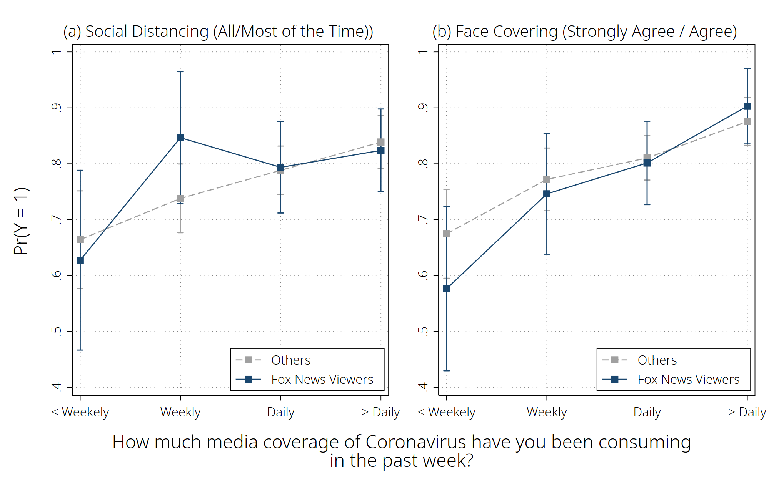

**Fig. 1 | Effect of Media Consumption of SARS-CoV-2 virus on the Extent of Complying with Social Distancing and Support for Requiring Face Covering.** The results are presented in eTable 3 in the supplementary material. The capped spikes mean 95% prediction intervals.

Figure 1 shows that both Fox News viewers (blue line) and the other respondents (dotted grey line) are more likely to answer that they keep social distancing all or most of the time (plot (a)) and agree with requiring face covering at public spaces when other covariates are controlled (plot (b).

Interestingly, in the group of Fox News viewers, the likelihood that the respondent who consumed the media coverage of SARS-CoV-2 virus less than weekly followed social distancing all or most of the time is 62.76 percentage points (95% CI = 46.68, 78.83). However, the likelihood increases to 84.66 percentage points (95% CI = 72.85, 96.46) for the weekly group, 79.37 percentage points (95% CI = 71.19, 87.54) for the daily group, and 82.39 percentage points (95% CI = 74.99, 89.79) for the group of multiple times a day. The same tendency is found among the other respondents. As the grey line shows, the other respondents are also more likely to answer that they keep social distancing when they are exposed to the media coverage of SARS-CoV-2 virus more frequently.

Plot (b) shows the same tendency in the case of the face-covering requirement in public spaces. The baseline likelihood is 57.65 percentage points (95% CI = 42.98, 72.32) among Fox News viewers. However, it increases to 74.61 percentage points (95% CI = 63.84, 85.39) for the weekly group, 80.15 percentage points (95% CI = 72.69, 87.61) for the daily group, and 90.30 percentage points (95% CI = 83.55, 97.06) for the group of multiple times a day. This tendency remains the same among the other respondents.

One might concern reverse causality (i.e., a higher media consumption of SARS-CoV-2 virus due to more anxiety about getting infected). However, the effect remained significant when we controlled for those who are not worried about contracting SARS-CoV-2 virus.

## COVID-19 Anxiety

Figure 2 shows that the degree of COVID-19 anxiety is strongly associated with the extent of media consumption among both Fox News viewers and the other respondents (see eTable 4 for more details of the result). We tested with four types of anxiety: contracting SARS-CoV-2 virus, serious complication or death from SARS-CoV-2 virus, effects of social distancing on the economy, and shortages of necessary items. The plots indicate that the respondents are more worried when they are exposed to the media coverage of SARS-CoV-2 virus more frequently, even when their primary source of media is Fox News.

Fox News viewers tend to be less worried about contracting SARS-CoV-2 virus or a serious complication on average than the other respondents among those who consumed the media coverage of SARS-CoV-2 virus weekly or less, as shown in plots (a) and (b). However, the differences disappear in the groups with more frequent media consumption.

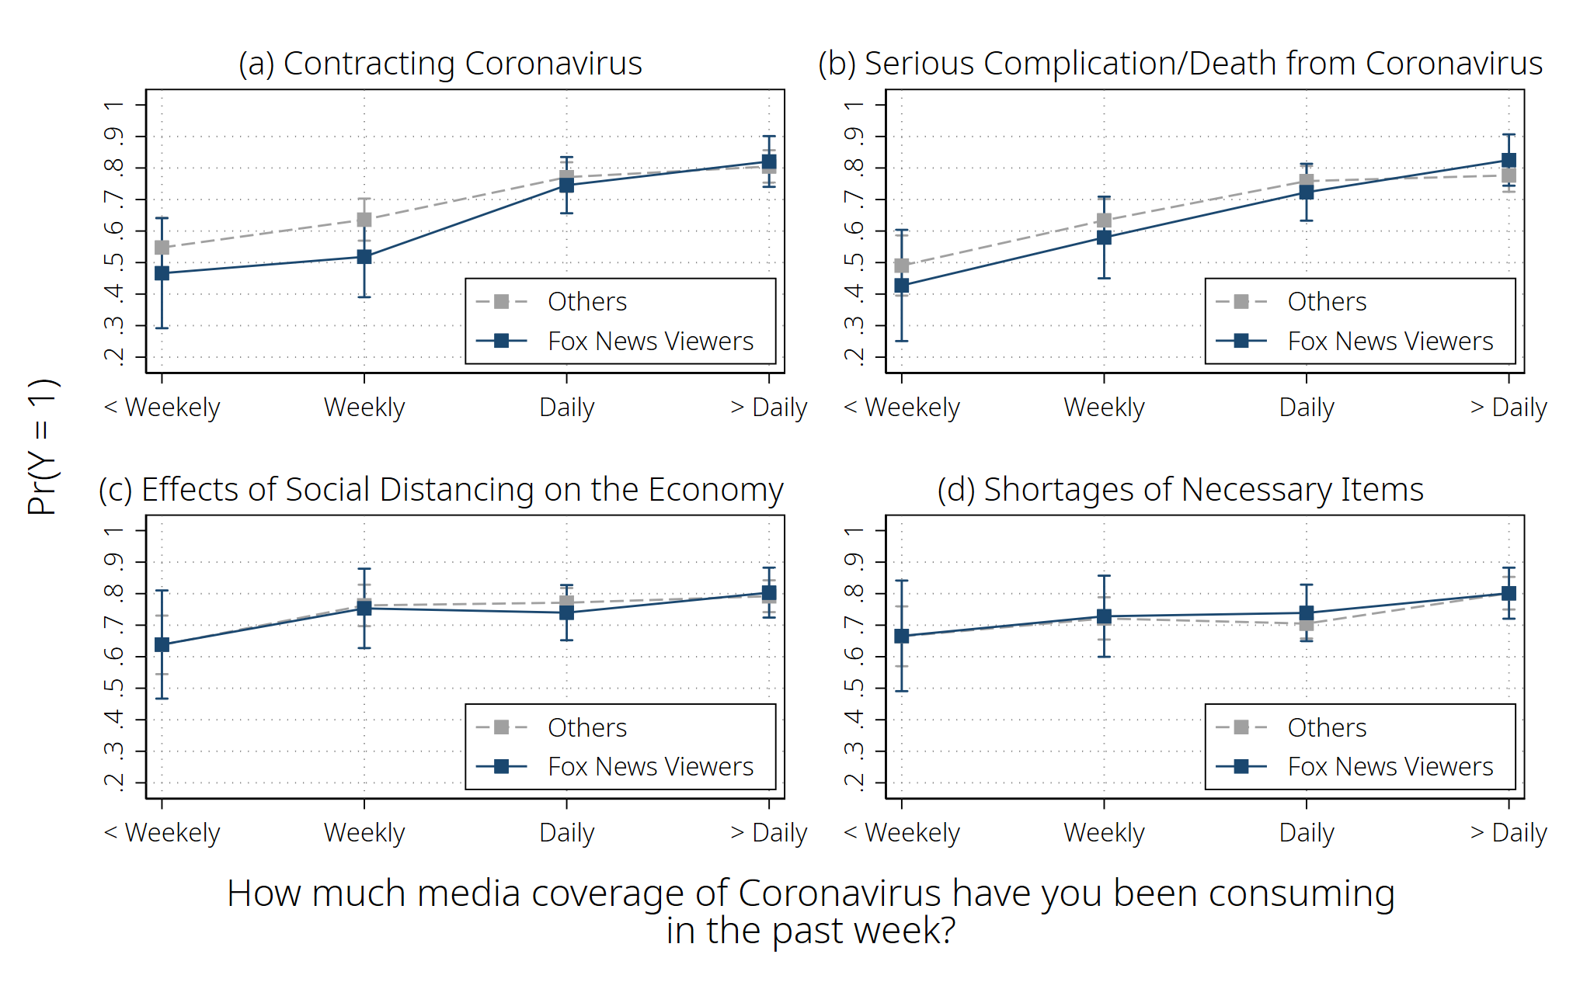

**Fig. 2 | Effect of Media Consumption of SARS-CoV-2 virus on the Degrees of COVID-19 Anxiety by Different Sources of Media Consumption.** The results are presented in eTable 4 in the supplementary material. The capped spikes mean 95% prediction intervals.

## Trust in Governments and Medical Scientists

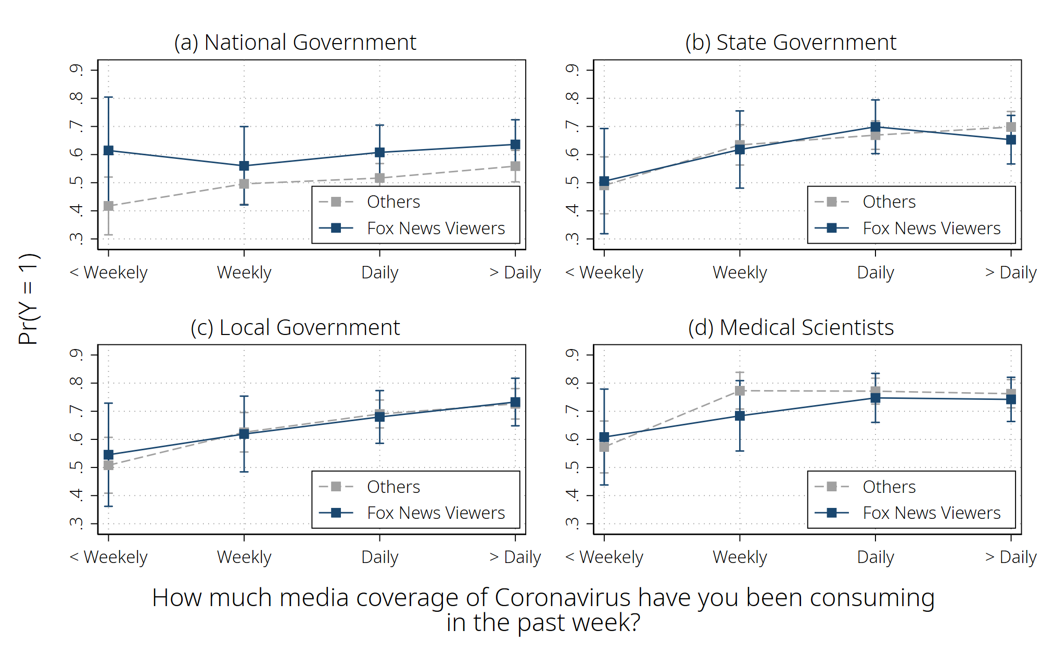

**Fig. 3 | Effect of Media Consumption of SARS-CoV-2 virus on the Degrees of Trust in Governments and Medical Scientists.** The results are presented in eTable 5 in the supplementary material. The capped spikes mean 95% prediction intervals.

Figure 3 shows the degree of confidence in governments and medical scientists increases along with the frequency of media consumption of SARS-CoV-2 virus in both groups of Fox News viewers and the others (see eTable 5 for more details of the result).

Fox News viewers show a higher trust in the national government (Fig. 3-a), which makes sense when considering that Fox News, in general, has been supportive of the Trump administration. However, for state and local governments and medical scientists, Fox News viewers and the other respondents consistently show similar levels of trust.

## Perceptions of the Government Response

Different from the results so far that highlighted the similarity between Fox News viewers and the others, Figure 4 shows a somewhat diverging tendency between the two groups when it comes to the government response to the pandemic (see eTable 6 for more details of the result). The question in plot (a) asks how much the respondents think that the government interferes too much. The plot shows that the likelihood of answering either “agree” or “agree strongly” more steeply increases along with the extent of media consumption of SARS-CoV-2 virus among Fox News Viewers than in the group of the other respondents. In the group of the media consumption multiple times a day, the likelihood is 20.79 percentage points higher among Fox News viewers (*BFox News* = 0.1655, 95% CI [-0.0501, 0.3811] and *BFox News x Media: More than daily* = 0.0424, 95% CI [-0.1969, 0.2817]).

The question in plot (b) asks how much the respondent thinks the government is overreacting to the pandemic. The result indicates that, overall, the respondents are less likely to agree with the statement when they are exposed to the media coverage of SARS-CoV-2 virus more frequently. However, the gap between Fox News viewers and the other respondents is not reduced along with the extent of media consumption. In the group of the media consumption multiple times a day, the likelihood that Fox News viewers agree with the statement remains 15.51 percentage points higher than that of the other respondents (*BFox News* = 0.0959, 95% CI [-0.0769, 0.2687] and *BFox News x Media: More than daily* = 0.0592, 95% CI [-0.1326, 0.2510]).

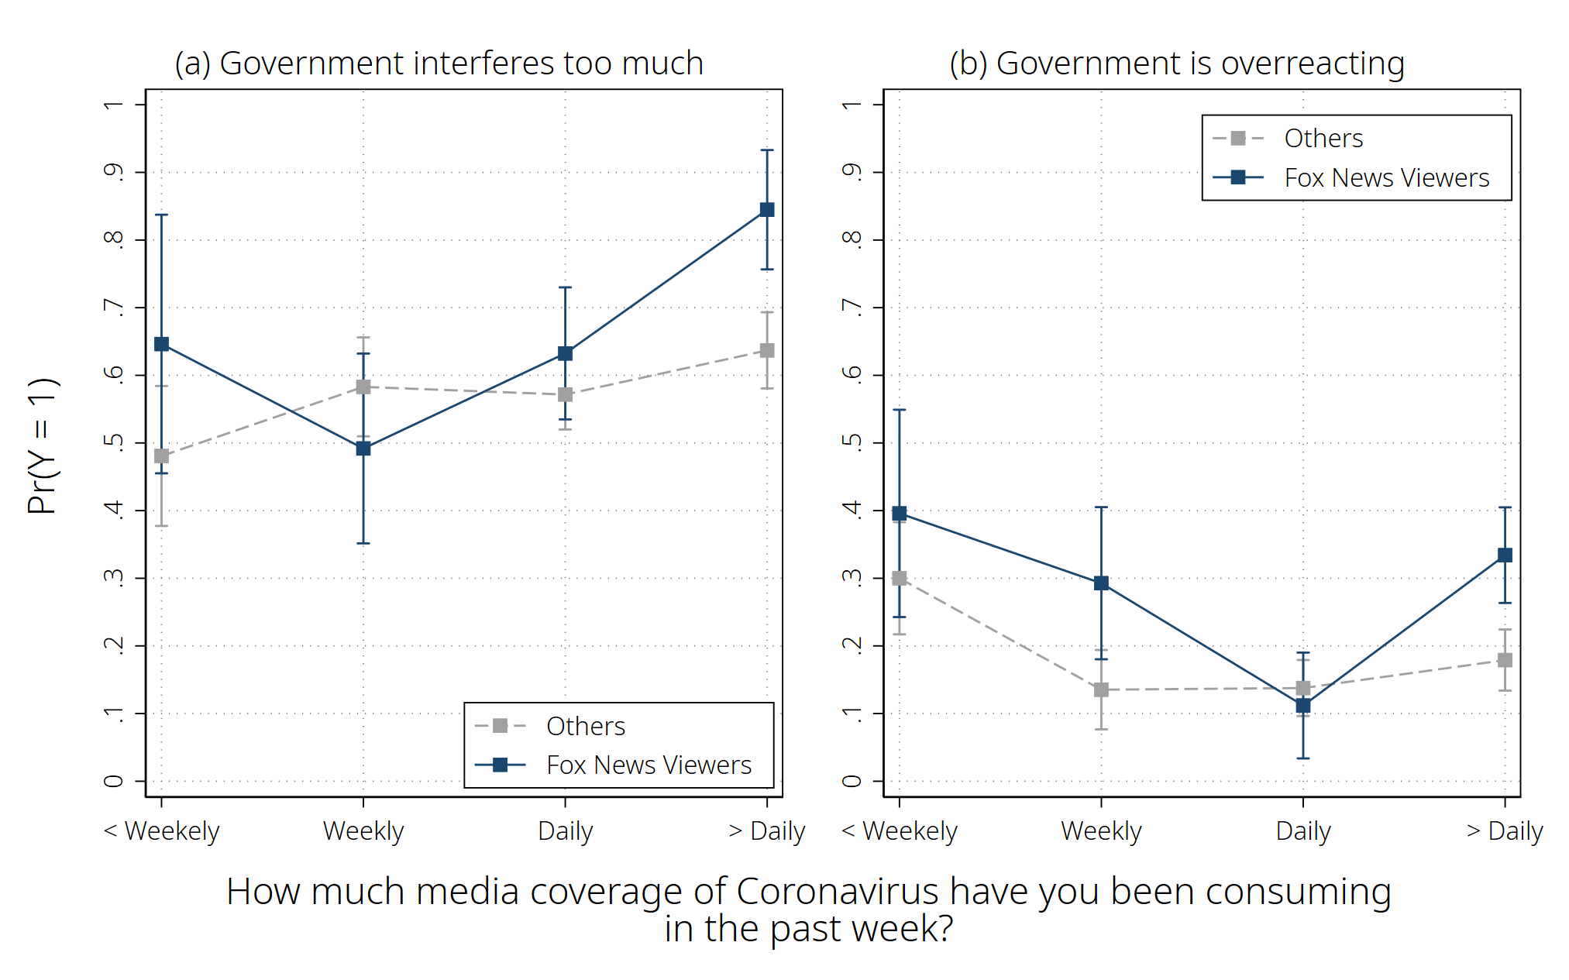

**Fig. 4 | Effect of Media Consumption of SARS-CoV-2 virus on Perceptions of Government Response to the COVID-19 Pandemic.** The results are presented in eTable 6 in the supplementary material. The capped spikes mean 95% prediction intervals.

# DISCUSSION

Before moving to the major discussion points, we would like to highlight to limitations inherent in our analysis. First, the results so far heavily rely on perceptual data. Thus, any interpretations of the results should not expand to explain a behavioural pattern. Second, we did not control for educational attainment in our models. We are aware that the educational level can be a confounding factor by affecting both the extent of media consumption and the understanding of the COVID-19 issues. This means that the magnitudes of the media consumption variables in our models might be adjusted if we control for the educational level. However, given that the estimated difference in the daily newspaper readership between the high school graduates and post-graduate degree holders is about 11 percentage points as of 201619, which is smaller than the influence of age20, we expect that the omission of the education level is not likely to undermine our findings seriously.

We examined the association between media consumption and people’s attitudes to COVID-19 issues. The results suggest that people are more likely to be supportive of social distancing and face-covering, worried about the COVID-19 issue, and trust in governments and medical scientists when they are exposed to the media coverage of SARS-CoV-2 virus more frequently. The effect of media consumption remained quite significant as well among Fox News viewers who are more likely to be exposed to messages that underestimate the COVID-19 pandemic and effectiveness of public health guidance. Prior studies aroused suspicion that politicized media outlets may encourage non-compliance with on-going prevention efforts of SARS-CoV-2 virus transmission by making people disbelieve in the seriousness of the COVID-19 issue and public health guidance1,2. However, our findings suggest that the motivation of the non-compliance may exist somewhere else and be moderated by threat perception.

Our findings primarily imply that mass media is still working as an influential medium of promoting public health recommendations for the general public in the COVID-19 pandemic. Studies often highlighted the dark side of mass media in the COVID-19 pandemic where public health issues are unnecessarily politicized1,11,12, however, it might not be the whole picture.

To advance the academic discussion on the non-compliance issue, we suggest potential mechanisms as hypotheses worth testing in future research. First, the negative effects of politicized media outlets might reflect differing viewpoints in the perception of the appropriate level of response of the government as well as misunderstanding of the COVID-19 issue. In other words, even though mass media have informed people of the current situation in the pandemic and improved the perception of the need for prevention efforts, people might understand how to cope with the infection differently21. In such a case, studies recommend indirectly stimulating the cognitive (or sometimes irrational) aspect to alter human behaviours, known as nudge, a concept from behavioural sciences22,23. Second, we also need to have a more precise understanding of how threat perception improves or undermines compliance with public health guidance and other human behaviours in the pandemic. Given that the COVID-19 anxiety increased along with the extent of media consumption in our analysis, simple exposure to increased media reports of SARS-CoV-2 virus, even if the messages are politicized, might have signalled threat and led its viewers to be aware of the public health recommendations. In the opposite case, however, this will be particularly important when it comes to the vaccine hesitancy issue, which is highly expected when the vaccine is available sooner or later. Even though our findings imply that the signal of danger might have helped mitigate the negative effect of media polarization over social distancing, if our hypothesis is true, that mechanism is likely to works in the opposite direction by making people more reluctant to get vaccinated.

# REFERENCES

1. Simonov, A., Sacher, S., Dube, J.-P. H. & Biswas, S. *The Persuasive Effect of Fox News: Non-Compliance with Social Distancing During the COVID-19 Pandemic*. *SSRN Electronic Journal* (2020) doi:10.2139/ssrn.3604214.

2. Gollwitzer, A. *et al.* Partisan Differences in Physical Distancing are Linked to Health Outcomes during the COVID-19 Pandemic. *Nat. Hum. Behav.* **4**, 1186–1197 (2020).

3. Bromwich, J. E. How to Wash Your Hands. *New York Times* (2020).

4. Or Fleisher, Gabriel Gianordoli, Yuliya Parshina-Kottas, Karthik Patanjali, Miles Peyton, and B. S. Masks Work. Really. We’ll Show You How. *2New York Times* (2020).

5. Lewnard, J. A. & Lo, N. C. Scientific and ethical basis for social-distancing interventions against COVID-19. *Lancet Infect. Dis.* **20**, 631–633 (2020).

6. Courtemanche, C., Garuccio, J., Le, A., Pinkston, J. & Yelowitz, A. Strong Social Distancing Measures In The United States Reduced The COVID-19 Growth Rate. *Health Aff. (Millwood).* **39**, 1237–1246 (2020).

7. MacIntyre, C. R. & Wang, Q. Physical Distancing, Face Masks, and Eye Protection for Prevention of COVID-19. *Lancet* **395**, 1950–1951 (2020).

8. Rubin, D. *et al.* Association of Social Distancing, Population Density, and Temperature With the Instantaneous Reproduction Number of SARS-CoV-2 in Counties Across the United States. *JAMA Netw. open* **3**, e2016099 (2020).

9. North, A. Why masks are (still) politicized in America. *Vox Media* (2020).

10. Rothgerber, H. *et al.* Politicizing the COVID-19 Pandemic: Ideological Differences in Adherence to Social Distancing. (2020) doi:10.31234/osf.io/k23cv.

11. Hall Jamieson, K. & Albarracín, D. The Relation between Media Consumption and Misinformation at the Outset of the SARS-CoV-2 Pandemic in the US. *Harvard Kennedy Sch. Misinformation Rev.* (2020) doi:10.37016/mr-2020-012.

12. Bursztyn, L., Rao, A., Roth, C. & Yanagizawa-Drott, D. Misinformation During a Pandemic. *SSRN Electron. J.* (2020) doi:10.2139/ssrn.3580487.

13. Albertson, B. & Gadarian, S. K. *Anxious Politics: Democratic Citizenship in a Threatening World*. *Anxious Politics* (Cambridge University Press, 2015). doi:10.1017/cbo9781139963107.

14. Druckman, J. N., Klar, S., Krupnikov, Y., Levendusky, M. & Ryan, J. B. Affective Polarization, Local Contexts and Public Opinion in America. *Nat. Hum. Behav.* (2020) doi:10.1038/s41562-020-01012-5.

15. Sanger-Katz, M. On Coronavirus, Americans Still Trust the Experts. *The New York Times* (2020).

16. Brenan, M. Amid Pandemic, Confidence in Key U.S. Institutions Surges. *Gallup* (2020).

17. Pierre, J. M. The psychology of guns: risk, fear, and motivated reasoning. *Palgrave Commun.* **5**, (2019).

18. Stroebe, W., Leander, N. P. & Kruglanski, A. W. Is It a Dangerous World Out There? The Motivational Bases of American Gun Ownership. *Personal. Soc. Psychol. Bull.* **43**, 1071–1085 (2017).

19. Pew Research Center. Newspapers: Daily Readership by Education Level (2016). *Pew Research Center* https://www.journalism.org/chart/5799/ (2016).

20. Pew Research Center. Newspapers: Daily Readership by Age (2016). *Pew Research Center* https://www.journalism.org/chart/5802/ (2016).

21. Kahan, D. & Braman, D. Cultural Cognition and Public Policy. *Yale Law Policy Rev.* **24**, 149–172 (2006).

22. Nivette, A. *et al.* Non-Compliance with COVID-19-Related Public Health Measures among Young Adults in Switzerland: Insights from a Longitudinal Cohort Study. *Soc. Sci. Med.* **268**, (2021).

23. Kim, J. *et al.* Nudging to Reduce the Perceived Threat of Coronavirus and Stockpiling Intention. *J. Advert.* 1–15 (2020) doi:10.1080/00913367.2020.1806154.